

BUS USERS INTERACTIVE NETWORK

SOFTWARE REQUIREMENT SPECIFICATION

**Project Code: BUIN**

**Document Code: BUIN_ Software requirement specification_v1.0_EN**

**- Hanoi, 06/2014 -**

**SIGNATURE PAGE**

|  |  |  |
| --- | --- | --- |
| AUTHOR: | Nguyen Thanh Nam  Project Manager (PM) | 03/06/2015 |
| REVIEWERS: | Trinh Thi Tuyet Mai  Test Leader | 03/06/2015 |
|  |  |
| Bui Bich Phuong  Tester | 03/06/2015 |
|  |  |
| APPROVAL: | Nguyen Van Sang  Supervisor | 19/06/2015 |
|  |  |

**Record of change**

*A - Added M - Modified D – Deleted

|  |  |  |  |  |  |  |
| --- | --- | --- | --- | --- | --- | --- |
| **Effective Date** | **Changed Item** | **A* M, D** | **Change Description** | **Reason for Change** | **Revision Number** | |
| 03/06/2015 | Add SRS | A | Create this document | First Version | v1.0 |
|  |  |  |  |  |  |
|  |  |  |  |  |  |

Table of Contents

1.1 Introduction 4

1.1.1 Purposes 4

1.1.2 Definition and Acronyms 5

1.2 System Purpose 5

1.3 Scope 5

1.4 Overall Description 5

1.4.1 System overview 5

1.4.2 Product Features 7

1.4.3 User Characteristics 10

1.4.4 User Documentation 10

1.4.5 Assumption 10

1.5 Entity Relation Model 11

1.5.1 Entity-Relationship Diagram 11

1.5.2 Entity Detail 11

1.6 Functional Specification 16

1.6.1 Common Module 16

1.6.2 Account management Module 26

1.6.3 Contact admin Module 39

1.6.4 Practice management Module 48

1.6.5 Admin’s account management 59

1.6.6 Management Member’s account 66

1.6.7 Vocabulary Management 73

1.6.8 Grammar Management 86

1.6.9 Reading Document Management 98

1.6.10 Conversation management 115

1.6.11 Video Management 129

1.6.12 Training Listening Management 138

1.6.13 Test management 152

1.6.14 Contact management 165

1.6.15 Contributed content management 173

1.7 Non-functional Specification 181

1.7.1 Reliability 181

1.7.2 Performance Requirements 181

1.7.3 User Interface 181

1.7.4 Maintainability 182

1.7.5 Usability 182

1.7.6 Security Requirements 182

1.7.7 Hardware/Software Requirements 182

## Introduction

### Purposes

This document is created for better understanding about our Capstone project – Bus User Interactive Network. In this document, we will provide an overview of all the functions and use cases of our system, and a brief description of our solution for designing the system. This document is based on thorough analysis of user requirements and other requirements.

### Definition and Acronyms

This section describes the definitions, terms, and acronyms that are used in software requirements specification.

|  |  |
| --- | --- |
| Acronym & Abbreviation | Definition |
| BUIN | Bus User Interaction Network |
| FU | FPT University |
| BU | Bus User |
| IN | Interactive Network |
| Q&A | Question and Answer |
|  |  |

**Table 1-1: Definition and Acronyms**

## System Purpose

The system is developed to make using buses easier and more convenient. It is hoped to create a habit of using public transportation in young people by making it more interesting and fun.

## Scope

This project will consist of creating an usable Android application that is connected to an .NET web service and runs smoothly on Android 4.4 and above devices. The project will be completed by August 28st, 2015. Main modules of the app will include Bus-Searching, Path-Finding, Schedule-Reminding and Interacting-Contents.

## Overall Description

### System overview

Nowadays, there are quite many apps and websites which support finding and making use of buses. All of them have been created for the purpose of making users easier to catch a bus or to travel from places to places using buses. However, we found disadvantages while trying each of them. Some have confusing UI, some are better yet only not functionally focused on bus services and have not much to offer to users. Therefore, our project BUIN offers almost everything a bus user in Vietnam, especially “everyday-bus-users” would need. Not only support users finding buses, setting routes, notifying upcoming trips… BUIN also renders a world of interactions with bus, makes each bus trip more interesting and meaning than just transportation. BUIN also support connecting and sharing on social network like Facebook, as well as ranking user base on their achievements. All of this would be done through a smartphone application which synchronized to the cloud service. Completely free of charge.

### Product Features

|  |  |  |  |
| --- | --- | --- | --- |
| **Use Case No.** | **Group of functions** | **Functions** | **Glossary** |
| **BUIN USER MODULES** | | | |
| **Account Management Module** | | | |
|  |  | Sign in | Đăng nhập |
|  | Sign up | Đăng ký |
|  | Sign out | Đăng xuất |
|  | Forgot Password | Quên mật khẩu |
|  | Change account info | Chỉnh sửa thông tin cá nhân |
| **Common Module** | | | |
|  |  | View dashboard | Xem bảng tin |
|  | Change app settings | Thay đổi cài đặt |
| **Bus Module** | | | |
|  |  | View bus list | Xem danh sách buýt |
|  | Search bus in list | Tìm kiếm trong danh sách buýt |
|  | View bus info | Xem thông tin của xe buýt |
|  | View bus route | Xem lộ trình của xe buýt |
|  | View nearest bus | Xem xe buýt gần nhất thuộc tuyến đã chọn |
|  | View bus map | Xem đường đi của xe buýt trên bản đồ |
|  | View bus near me | Xem tất cả các xe buýt ở gần |
| **Path Finder Module** | | | |
|  |  | Find path | Tìm đường |
|  | View paths found | Xem kết quả tìm được |
|  | View path detail | Xem chi tiết đường đi |
|  | View direction | Nghe hội thoại |
| **Reminder module** | | | |
|  |  | View bus reminder | Xem tất cả nhắc nhở |
|  | Add reminder | Thêm nhắc nhở |
|  | Edit reminder | Sửa nhắc nhở |
|  | Delete reminder | Xoá nhắc nhở |
|  | Suspend/Unsuspend all reminder | Hoãn/Ngừng hoãn tất cả nhắc nhở |
|  | Suspend/Unsuspend a chosen reminder | Hoãn/Ngừng hoãn một nhắc nhở đã chọn |
| **Track module** | | | |
|  |  | Set track | Theo dõi |
|  | Cancel tracker | Ngừng theo dõi |
| **Favorite Module** | | | |
|  |  | View favorite places | Xem địa điểm yêu thích |
|  | Add favorite place | Thêm địa điểm yêu thích |
|  | Edit favorite place | Sửa địa điểm yêu thích |
|  | Delete favorite place | Xoá địa điểm yêu thích |
|  | Search favorite places | Tìm kiếm địa điểm yêu thích |
|  | View favorite buses | Xem xe buýt yêu thích |
|  | Add favorite bus | Thêm xe buýt yêu thích |
|  | Delete favorite bus | Xoá xe buýt yêu thích |
|  | Search favorite buses | Tìm kiếm xe buýt yêu thích |

### User Characteristics

This application is developed towards young people who are using bus every day or have the need to use bus as their main transportation vehicle. The system requires users to have an Android smartphone with an active internet connection and GPS enabled. Users can freely use all functions without any limitation but to save their usage data and interactive progress, they must log in – which requires only a minimum number of information and steps.

### User Documentation

List of document when delivering this application is in the table below:

|  |  |
| --- | --- |
| **Name** | **Description** |
| User Manual | Provide detailed explanation about the system, screens and guide users how to use all features of BUIN system. |

### Assumption

* On each bus, there is a GPS device which is able to submit JSON over 3G network.
* Reviewers will have seven days to approve a milestone document. If no comments were received within this time period, the documents would be considered approved.
* There is a distinct QR-Code for each bus number, which is used to fill users’ Collection.

## Entity Relation Model

### Entity-Relationship Diagram

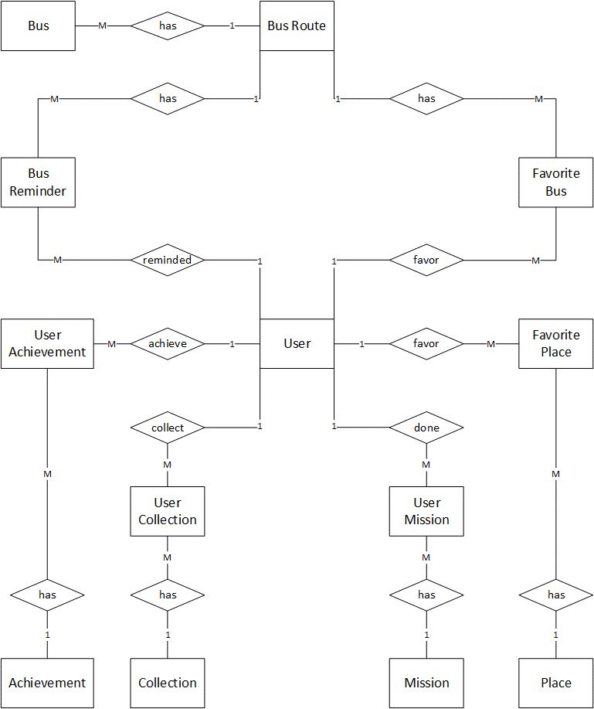

### Entity Detail

#### Bus

|  |  |  |  |  |
| --- | --- | --- | --- | --- |
| No | Field Name | Type | Mandatory | Description |
|  | bus_id | String | Y | Bus’s id |
|  | bus_route_id | Number | Y | Bus route’s number |

#### Bus Route

|  |  |  |  |  |
| --- | --- | --- | --- | --- |
| No | Field Name | Type | Mandatory | Description |
|  | bus_route_id | Number | Y | Bus route’s id |
|  | bus_route_away | String | Y | Bus away route |
|  | bus_route_back | String | Y | Bus back route |
|  | bus_route_start_time | Time | Y | Bus route start time |
|  | bus_route_end_time | Time | Y | Bus route end time |
|  | bus_route_time_each | Time | Y | Bus route time between two bus |

#### Bus Reminder

|  |  |  |  |  |
| --- | --- | --- | --- | --- |
| No | Field Name | Type | Mandatory | Description |
|  | user_id | Number | Y | User’s id |
|  | bus_route_id | Number | Y | Bus route’s id |
|  | bus_reminder_route_direction | String | Y | Bus reminder’s route direction |
|  | bus_reminder_time | Time | Y | Bus reminder’s time |
|  | bus_reminder_location_name | String | Y | Bus reminder’s location name |
|  | bus_reminder_locationX | Number | Y | Bus reminder’s location X |
|  | bus_reminder_locationY | Number | Y | Bus reminder’s location Y |
|  | bus_reminder_is_monday | Boolean | Y | Bus reminder is on Monday? |
|  | bus_reminder_is_tuesday | Boolean | Y | Bus reminder is on Tuesday? |
|  | bus_reminder_is_wednesday | Boolean | Y | Bus reminder is on Wednesday? |
|  | bus_reminder_is_thursday | Boolean | Y | Bus reminder is on Thursday? |
|  | bus_reminder_is_friday | Boolean | Y | Bus reminder is on Friday? |
|  | bus_reminder_is_saturday | Boolean | Y | Bus reminder is on Saturday? |
|  | bus_reminder_is_sunday | Boolean | Y | Bus reminder is on Sunday? |
|  | bus_reminder_repeat | Number | Y | Bus reminder is repeated? |
|  | bus_reminder_distane | Number | Y | Bus reminder’s distance from bus to bus stop |
|  | bus_reminder_repeat_time | Time | Y | Bus reminder’s repeat time |

#### Favorite Bus

|  |  |  |  |  |
| --- | --- | --- | --- | --- |
| No | Field Name | Type | Mandatory | Description |
|  | user_id | Number | Y | User’s id |
|  | bus_route_id | Number | Y | Bus route’s id |

#### User

|  |  |  |  |  |
| --- | --- | --- | --- | --- |
| No | Field Name | Type | Mandatory | Description |
|  | user_id | Number | Y | User’s id |
|  | user_email | String | Y | User’s email |
|  | user_password | String | Y | User’s password |

#### Place

|  |  |  |  |  |
| --- | --- | --- | --- | --- |
| No | Field Name | Type | Mandatory | Description |
|  | place_id | Number | Y | Place’s id |
|  | place_name | String | Y | Place’s name |
|  | place_locationX | Number | Y | Place’s location X |
|  | place_locationY | Number | Y | Place’s location Y |

#### Favorite Place

|  |  |  |  |  |
| --- | --- | --- | --- | --- |
| No | Field Name | Type | Mandatory | Description |
|  | user_id | Number | Y | User’s id |
|  | place_id | String | Y | Place’s id |
|  | favorite_place_name | String | Y | Favorite place’s name |

## Functional Specification

### Account management module

#### Use case diagram

#### UC0001: Sign in

##### Screen definition

##### Use Case Specification

|  |  |  |  |  |
| --- | --- | --- | --- | --- |
| **Use Case ID** | | UC0001 | **Version** | 1.0 |
| **Use Name** | | Sign in | | |
| **Actor** | | BUIN User | | |
| **Description** | | The function allows an user to sign in. | | |
| **Precondition** | | User have registered account but not log in yet | | |
| **Trigger** | | User tap “Đăng nhập” button | | |
| **Post-Condition** | | “Dashboard” screen is shown | | |
| **Main flows** | | | | |
| **Step** | **Actor** | **Action** | | |
| 1 | BUIN User | Open the BUIN app | | |
| 2 | BUIN | Display “Đăng nhập” screen | | |
| 3 | BUIN User | Inputs email and password, then taps “Đăng nhập” button | | |
| 4 | BUIN | Validates information and logs user into app then moves to Dashboard screen. | | |
|  |  |  | | |
|  | | | | |

**Exception**

|  |  |  |
| --- | --- | --- |
| **E1** | At step 3 in the main flows**,** if BUIN User leave either email or password blank | |
| **Step** | **Actor** | **Action** |
| 4.1 | BUIN | Returns popup with Error message “Vui lòng nhập đầy đủ thông tin.” |
|  |  |  |

|  |  |  |
| --- | --- | --- |
| **E2** | At step 4 in the main flows**,** if BUIN failed to validate email & password | |
| **Step** | **Actor** | **Action** |
| 4.2 | BUIN | Returns popup with Error message “Email hoặc mật khẩu không hợp lệ. Vui lòng nhập lại” |
|  |  |  |

#### UC0002: Sign up

##### Screen definition

##### Use Case Specification

|  |  |  |  |  |
| --- | --- | --- | --- | --- |
| **Use Case ID** | | UC0002 | **Version** | 1.0 |
| **Use Name** | | Sign up | | |
| **Actor** | | BUIN User | | |
| **Description** | | The function allows an user to sign up an account in order to sign in. | | |
| **Precondition** | | User didn’t have account | | |
| **Trigger** | | User tap “Đăng ký” button | | |
| **Post-Condition** | | “Đăng ký” screen is shown | | |
| **Main flows** | | | | |
| **Step** | **Actor** | **Action** | | |
| 1 | BUIN User | Open the BUIN app and tap “Đăng ký” button | | |
| 2 | BUIN | Display “Đăng ký” screen | | |
| 3 | BUIN User | Inputs email and password, then taps “Đăng ký” button | | |
| 4 | BUIN | Validates information and logs user into app then moves to “Đăng nhập” screen and notify user that sign up was complete. | | |
|  |  |  | | |
|  | | | | |

**Exception**

|  |  |  |
| --- | --- | --- |
| **E1** | At step 3 in the main flows**,** if BUIN User leave either email or password blank | |
| **Step** | **Actor** | **Action** |
| 4.1 | BUIN | Returns popup with Error message “Vui lòng nhập đầy đủ thông tin.” |
|  |  |  |

|  |  |  |
| --- | --- | --- |
| **E2** | At step 4 in the main flows**,** if BUIN failed to validate email & password | |
| **Step** | **Actor** | **Action** |
| 4.2 | BUIN | Returns popup with Error message “Email hoặc mật khẩu không hợp lệ. Vui lòng nhập lại” |
|  |  |  |

#### UC0003: Sign out

##### Screen definition

##### Use Case Specification

|  |  |  |  |  |
| --- | --- | --- | --- | --- |
| **Use Case ID** | | UC0003 | **Version** | 1.0 |
| **Use Name** | | Sign out | | |
| **Actor** | | BUIN User | | |
| **Description** | | The function allows an user to sign up an account in order to sign in. | | |
| **Precondition** | | User have logged in | | |
| **Trigger** | | User tap “Đăng xuất” button | | |
| **Post-Condition** | | “Đăng nhập” screen is shown | | |
| **Main flows** | | | | |
| **Step** | **Actor** | **Action** | | |
| 1 | BUIN User | Tap “Đăng xuất” button | | |
| 2 | BUIN | Sign user out and display “Đăng nhập” screen | | |
|  |  |  | | |
|  | | | | |

#### UC0004: Forgot password

##### Screen definition

##### Use Case Specification

|  |  |  |  |  |
| --- | --- | --- | --- | --- |
| **Use Case ID** | | UC0004 | **Version** | 1.0 |
| **Use Name** | | Forgot password | | |
| **Actor** | | BUIN User | | |
| **Description** | | The function allows an user to receive their password if they forgot. | | |
| **Precondition** | | User haven’t logged in | | |
| **Trigger** | | User tap “Quên mật khẩu” button | | |
| **Post-Condition** | | “Quên mật khẩu” screen is shown | | |
| **Main flows** | | | | |
| **Step** | **Actor** | **Action** | | |
| 1 | BUIN User | Enters BUIN app | | |
| 2 | BUIN | Displays “Quên mật khẩu” screen | | |
| 3 | BUIN User | Enter email and click “Lấy lại mật khẩu” button | | |
| 4 | BUIN | Validate email and send password info to inputted email | | |
|  | | | | |

**Exception**

|  |  |  |
| --- | --- | --- |
| **E1** | At step 3 in the main flows**,** if BUIN User leave email blank | |
| **Step** | **Actor** | **Action** |
| 4.1 | BUIN | Returns popup with Error message “Vui lòng nhập đầy đủ thông tin.” |
|  |  |  |

|  |  |  |
| --- | --- | --- |
| **E2** | At step 4 in the main flows**,** if BUIN failed to validate email | |
| **Step** | **Actor** | **Action** |
| 4.2 | BUIN | Returns popup with Error message “Email không hợp lệ. Vui lòng nhập lại” |
|  |  |  |

#### UC0005: Change profile info

##### Screen definition

##### Use Case Specification

|  |  |  |  |  |
| --- | --- | --- | --- | --- |
| **Use Case ID** | | UC0005 | **Version** | 1.0 |
| **Use Name** | | Change profile info | | |
| **Actor** | | BUIN User | | |
| **Description** | | The function allows an user to change his/her account profile info | | |
| **Precondition** | | User have logged in | | |
| **Trigger** | | User taps Change account info item | | |
| **Post-Condition** | | Change account info popup is shown | | |
| **Main flows** | | | | |
| **Step** | **Actor** | **Action** | | |
| 1 | BUIN User | Enters BUIN app | | |
| 2 | BUIN | Displays Dashboard screen | | |
| 3 | BUIN User | Taps menu button | | |
| 4 | BUIN | Display Menu | | |
| 5 | BUIN User | Taps Change account info item | | |
| 6 | BUIN | Displays Change account info popup | | |
| 7 | BUIN User | Edits Password and Avatar then taps Save button | | |
| 8 | BUIN | System will validate and save the changes, then move to Dashboard screen with Menu shown | | |
|  | | | | |

**Exception**

|  |  |  |
| --- | --- | --- |
| **E1** | At step 7 in the main flows**,** if BUIN User leave either email or password blank | |
| **Step** | **Actor** | **Action** |
| 8.1 | BUIN | Returns popup with Error message “Vui lòng nhập đầy đủ thông tin.” |
|  |  |  |

|  |  |  |
| --- | --- | --- |
| **E2** | At step 8 in the main flows**,** if BUIN failed to validate email & password | |
| **Step** | **Actor** | **Action** |
| 8.2 | BUIN | Returns popup with Error message “Email và password không hợp lệ. Vui lòng nhập lại” |
|  |  |  |

### Common module

#### Use case diagram

#### UC0006: View dashboard

##### Screen definition

##### Use Case Specification

|  |  |  |  |  |
| --- | --- | --- | --- | --- |
| **Use Case ID** | | UC0006 | **Version** | 1.0 |
| **Use Name** | | View dashboard | | |
| **Actor** | | BUIN User | | |
| **Description** | | The function allows an user to view dashboard | | |
| **Precondition** | | User have logged in | | |
| **Trigger** | | User opens app | | |
| **Post-Condition** | | “Dashboard” screen is shown | | |
| **Main flows** | | | | |
| **Step** | **Actor** | **Action** | | |
| 1 | BUIN User | Enters BUIN app | | |
| 2 | BUIN | Displays “Dashboard” screen | | |
|  | | | | |

#### UC0007: Change app setting

##### Screen definition

##### Use Case Specification

|  |  |  |  |  |
| --- | --- | --- | --- | --- |
| **Use Case ID** | | UC0007 | **Version** | 1.0 |
| **Use Name** | | Change app setting | | |
| **Actor** | | BUIN User | | |
| **Description** | | The function allows an user to change app setting | | |
| **Precondition** | | Dashboard screen displayed | | |
| **Trigger** | | User taps Menu then taps Setting item | | |
| **Post-Condition** | | Setting screen is shown | | |
| **Main flows** | | | | |
| **Step** | **Actor** | **Action** | | |
| 1 | BUIN User | Taps “Menu” button then tap “Settings” button | | |
| 2 | BUIN | Displays Settings screen | | |
| 3 | BUIN User | Taps Language dropdown then chooses any item in list | | |
| 4 | BUIN | The information of Setting field is changed | | |
| 5 | BUIN User | Taps “Nhắc nhở về xe buýt được chọn mỗi X phút” then inputs number | | |
| 6 | BUIN | The information of “Nhắc nhở về xe buýt được chọn mỗi X phút” field is changed | | |
| 7 | BUIN User | Taps “Tắt tất cả nhắc nhở”/ “Tắt tất cả thông báo" switch button | | |
| 8 | BUIN | “Tắt tất cả nhắc nhở”/ “Tắt tất cả thông báo" switch button changes status | | |
| 9 | BUIN User | Taps Done button | | |
| 10 | BUIN | Saves all edited information and move to Dashboard screen | | |
|  | | | | |

**Alternative scenario**

|  |  |  |
| --- | --- | --- |
| **AT1** | At step 3 in the main flows**,** if BUIN User doesn’t change anything and taps Done button | |
| **Step** | **Actor** | **Action** |
| 4.1 | BUIN | Nothing is changed and moves to Dashboard screen |
|  |  |  |

**Exception**

|  |  |  |
| --- | --- | --- |
| **E1** | At step 5 in the main flows**,** if BUIN User inputs 0 into “Nhắc nhở về xe buýt được chọn mỗi X phút” field then taps Done button | |
| **Step** | **Actor** | **Action** |
| 6.1 | BUIN | Returns popup with Error message “Xin vui lòng nhập số lớn hơn 0.” |
|  |  |  |

### Bus module

#### Use case diagram

#### UC0009: View bus list

##### Screen definition

##### Use Case Specification

|  |  |  |  |  |
| --- | --- | --- | --- | --- |
| **Use Case ID** | | UC0009 | **Version** | 1.0 |
| **Use Name** | | View bus list | | |
| **Actor** | | BUIN User | | |
| **Description** | | The function allows a user to view bus list. | | |
| **Precondition** | | Dashboard screen displayed | | |
| **Trigger** | | User taps Menu then taps Bus List item | | |
| **Post-Condition** | | Bus List screen is displayed | | |
| **Main flows** | | | | |
| **Step** | **Actor** | **Action** | | |
| 1 | BUIN User | Taps on Menu then taps on “Tuyến xe” button | | |
| 2 | BUIN | Display “Tuyến xe” screen | | |
|  | | | | |

#### UC0010: Search bus in list

##### Screen definition

##### Use Case Specification

|  |  |  |  |  |
| --- | --- | --- | --- | --- |
| **Use Case ID** | | UC0010 | **Version** | 1.0 |
| **Use Name** | | Search bus in list | | |
| **Actor** | | BUIN User | | |
| **Description** | | The function allows a user to search bus in the bus list. | | |
| **Precondition** | | Bus List screen displayed | | |
| **Trigger** | | User | | |
| **Post-Condition** | |  | | |
| **Main flows** | | | | |
| **Step** | **Actor** | **Action** | | |
| 1 | BUIN User | Taps on Search item on the top of screen | | |
| 2 | BUIN | Display Search form on Search bar | | |
| 3 | BUIN User | Inputs search keyword | | |
| 4 | BUIN | Searches and displays results | | |
|  | | | | |

#### UC0011: View bus info

##### Screen definition

##### Use Case Specification

|  |  |  |  |  |
| --- | --- | --- | --- | --- |
| **Use Case ID** | | UC0011 | **Version** | 1.0 |
| **Use Name** | | View bus info | | |
| **Actor** | | BUIN User | | |
| **Description** | | The function allows a user to view all information of a bus. | | |
| **Precondition** | | Bus List screen displayed | | |
| **Trigger** | | User taps on one bus | | |
| **Post-Condition** | | Bus Detail screen displayed | | |
| **Main flows** | | | | |
| **Step** | **Actor** | **Action** | | |
| 1 | BUIN User | Taps on a bus item. | | |
| 2 | BUIN | Displays Bus Detail screen. | | |
|  | | | | |

#### UC0012: View bus route

##### Screen definition

##### Use Case Specification

|  |  |  |  |  |
| --- | --- | --- | --- | --- |
| **Use Case ID** | | UC0012 | **Version** | 1.0 |
| **Use Name** | | View bus route | | |
| **Actor** | | BUIN User | | |
| **Description** | | The function allows a user to view route of a chosen bus. | | |
| **Precondition** | | Bus Detail screen displayed | | |
| **Trigger** | | User taps on Route tab | | |
| **Post-Condition** | | Bus Detail tab Route displayed | | |
| **Main flows** | | | | |
| **Step** | **Actor** | **Action** | | |
| 1 | BUIN User | Taps on Route tab on the Bus Detail screen. | | |
| 2 | BUIN | Displays Bus Detail screen with the Route tab. | | |
|  | | | | |

#### UC0013: View nearest bus

##### Screen definition

##### Use Case Specification

|  |  |  |  |  |
| --- | --- | --- | --- | --- |
| **Use Case ID** | | UC0013 | **Version** | 1.0 |
| **Use Name** | | View nearest bus | | |
| **Actor** | | BUIN User | | |
| **Description** | | The function allows a user to view all nearest bus of the chosen bus route. | | |
| **Precondition** | | Bus Detail screen displayed | | |
| **Trigger** | | User taps on Nearest tab | | |
| **Post-Condition** | | Bus Detail tab Nearest displayed | | |
| **Main flows** | | | | |
| **Step** | **Actor** | **Action** | | |
| 1 | BUIN User | Taps on Nearest tab on the Bus Detail screen. | | |
| 2 | BUIN | Displays Bus Detail screen with the Nearest tab. | | |
|  | | | | |

#### UC0014: View bus map

##### Screen definition

##### Use Case Specification

|  |  |  |  |  |
| --- | --- | --- | --- | --- |
| **Use Case ID** | | UC0014 | **Version** | 1.0 |
| **Use Name** | | View bus map | | |
| **Actor** | | BUIN User | | |
| **Description** | | The function allows a user to view route of a chosen bus on the map. | | |
| **Precondition** | | Bus Detail screen displayed | | |
| **Trigger** | | User taps on Map tab | | |
| **Post-Condition** | | Bus Detail tab Map displayed | | |
| **Main flows** | | | | |
| **Step** | **Actor** | **Action** | | |
| 1 | BUIN User | Taps on Map tab on the Bus Detail screen. | | |
| 2 | BUIN | Displays Bus Detail screen with the Map tab. | | |
|  | | | | |

#### UC0015: View bus near me

##### Screen definition

##### Use Case Specification

|  |  |  |  |  |
| --- | --- | --- | --- | --- |
| **Use Case ID** | | UC0015 | **Version** | 1.0 |
| **Use Name** | | View bus near me | | |
| **Actor** | | BUIN User | | |
| **Description** | | The function allows a user to view all buses near his/her current location. | | |
| **Precondition** | | Dashboard screen displayed | | |
| **Trigger** | | User taps Bus near me button | | |
| **Post-Condition** | | Bus near me screen displayed | | |
| **Main flows** | | | | |
| **Step** | **Actor** | **Action** | | |
| 1 | BUIN User | Taps on Bus near me button. | | |
| 2 | BUIN | Displays Bus near me screen. | | |
|  | | | | |

### Path finder module

#### Use case diagram

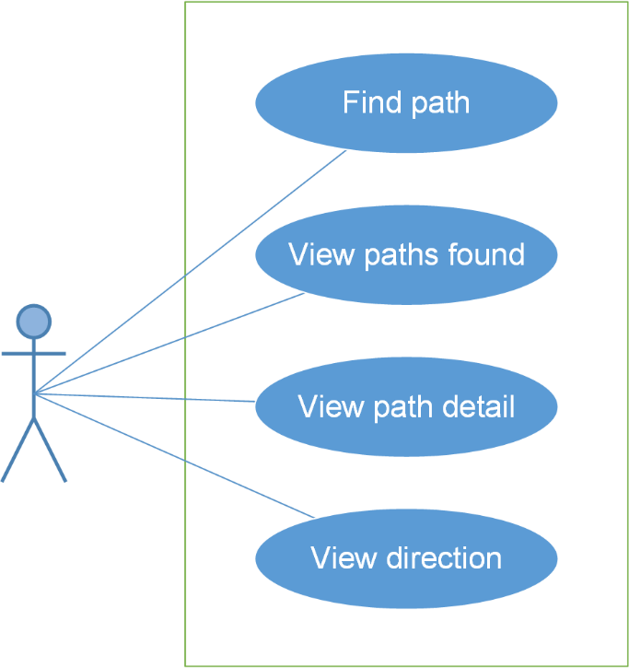

#### UC0016: Find path

##### Screen definition

##### Use Case Specification

|  |  |  |  |  |
| --- | --- | --- | --- | --- |
| **Use Case ID** | | UC0016 | **Version** | 1.0 |
| **Use Name** | | Find path | | |
| **Actor** | | BUIN User | | |
| **Description** | | The function allows an user to find path | | |
| **Precondition** | |  | | |
| **Trigger** | | User taps “Tìm đường” button | | |
| **Post-Condition** | | “Tìm đường” screen is shown | | |
| **Main flows** | | | | |
| **Step** | **Actor** | **Action** | | |
| 1 | BUIN User | Enters BUIN app | | |
| 2 | BUIN | Displays “Dashboard” screen | | |
| 3 | BUIN User | Taps “Tìm đường” button | | |
| 4 | BUIN | Display “Tìm đường” screen | | |
| 5 | BUIN User | In “Bản đồ” tab, inputs departure into “Điểm đi” text field and destination into “Điểm đến” text field then taps “Tìm” button | | |
| 6 | BUIN | Searches and displays found paths | | |
|  | | | | |

**Alternative scenario**

|  |  |  |
| --- | --- | --- |
| **AT1** | At step 5 in the main flows**,** if BUIN User inputs “Điểm đi” and “Điểm đến” text field then taps Revert direction button then taps “Tìm” button | |
| **Step** | **Actor** | **Action** |
| 6.1 | BUIN | Swaps 2 locations then searches and displays found paths |
|  |  |  |

|  |  |  |
| --- | --- | --- |
| **AT2** | At step 5 in the main flows**,** in “Bản đồ” tab, if BUIN User taps “Vị trí hiện tại” button in order to input “Điểm đi”/ “Điểm đến” text field and inputs the other text field then taps “Tìm” button | |
| **Step** | **Actor** | **Action** |
| 6.2 | BUIN | Returns user’s current location into that text field then searches and displays found paths |
|  |  |  |

|  |  |  |
| --- | --- | --- |
| **AT3** | At step 3 in the main flows**,** in “Dashboard” screen, if BUIN User taps “Tìm đường” button | |
| **Step** | **Actor** | **Action** |
| 4.3 | BUIN | Display “Tìm đường” screen |
|  |  |  |

|  |  |  |
| --- | --- | --- |
| **AT4** | At step 5 in the main flows**,** in “Bản đồ” tab, if BUIN User chooses locations on map in order to input “Điểm đi” and “Điểm đến” text field then taps “Tìm” button | |
| **Step** | **Actor** | **Action** |
| 6.4 | BUIN | Returns locations into “Điểm đi”/ “Điểm đến” text field then searches and displays found paths |
|  |  |  |

|  |  |  |
| --- | --- | --- |
| **AT5** | At step 5 in the main flows**,** if BUIN User taps “Lịch sử” tab then chooses places for “Điểm đi”/ “Điểm đến” text field then taps “Tìm” button | |
| **Step** | **Actor** | **Action** |
| 6.5 | BUIN | Displays places which were found before then searches and displays found paths |
|  |  |  |

|  |  |  |
| --- | --- | --- |
| **AT6** | At step 5 in the main flows**,** if BUIN User taps “Yêu thích” tab then chooses places for “Điểm đi”/ “Điểm đến” text field then taps “Tìm” button | |
| **Step** | **Actor** | **Action** |
| 6.6 | BUIN | Displays favorite places which were set before then searches and displays found paths |
|  |  |  |

**Exception**

|  |  |  |
| --- | --- | --- |
| **E1** | At step 5 in the main flows**,** if BUIN User inputs a place, which doesn’t exist, into “Điểm đi”/ “Điểm đến” text field then taps “Tìm” button | |
| **Step** | **Actor** | **Action** |
| 6.1 | BUIN | Returns popup with Error message “Điểm đi/ Điểm đến không tồn tại” |
|  |  |  |

|  |  |  |
| --- | --- | --- |
| **E2** | At step 5 in the main flows**,** if BUIN User leaves “Điểm đi”/ “Điểm đến” text field blank then taps “Tìm” button | |
| **Step** | **Actor** | **Action** |
| 6.2 | BUIN | Returns popup with Error message “Vui lòng nhập đầy đủ thông tin” |
|  |  |  |

|  |  |  |
| --- | --- | --- |
| **E3** | At step 5 in the main flows**,** if BUIN User inputs “Điểm đi” and “Điểm đến” text field then taps Search button without Internet | |
| **Step** | **Actor** | **Action** |
| 6.3 | BUIN | Returns popup with Error message “Thiết bị không kết nối mạng” |
|  |  |  |

#### UC0017: View path found

##### Screen definition

##### Use Case Specification

|  |  |  |  |  |
| --- | --- | --- | --- | --- |
| **Use Case ID** | | UC0017 | **Version** | 1.0 |
| **Use Name** | | View path found | | |
| **Actor** | | BUIN User | | |
| **Description** | | The function allows an user to view path found | | |
| **Precondition** | | “Tìm đường” screen displayed | | |
| **Trigger** | | User taps “Tìm” button | | |
| **Post-Condition** | | “Xem đường tìm được” screen is shown | | |
| **Main flows** | | | | |
| **Step** | **Actor** | **Action** | | |
| 1 | BUIN User | Enters “Tìm đường” screen, inputs informations and taps “Tìm” button | | |
| 2 | BUIN | * Searches and displays list of found paths in Paths found screen. * “Điểm đi”/ “Điểm đến” text field and Revert direction button will be disable. * A path will show the following information: total distance , walking distance, the number of exchange | | |
| 3 | BUIN User | Taps “Quãng đường ngắn nhất” tab | | |
| 4 | BUIN | Displays list paths found by filter: “Ngắn nhất” | | |
|  | | | | |

**Alternative scenario**

|  |  |  |
| --- | --- | --- |
| **AT1** | At step 3 in the main flows**,** if BUIN User taps “Chuyển tuyến ít nhất ” tab | |
| **Step** | **Actor** | **Action** |
| 4.1 | BUIN | Displays list paths found by filter: “Chuyển tuyến ít nhất” |

|  |  |  |
| --- | --- | --- |
| **AT2** | At step 3 in the main flows**,** in “Bản đồ” tab, if BUIN User taps “Đi bộ ít nhất” tab | |
| **Step** | **Actor** | **Action** |
| 4.2 | BUIN | Displays list paths found by filter: “Đi bộ ít nhất” |

#### UC0018: View path detail

##### Screen definition

##### Use Case Specification

|  |  |  |  |  |
| --- | --- | --- | --- | --- |
| **Use Case ID** | | UC0018 | **Version** | 1.0 |
| **Use Name** | | View path detail | | |
| **Actor** | | BUIN User | | |
| **Description** | | The function allows an user to view path detail | | |
| **Precondition** | | “Xem đường tìm được” screen displayed | | |
| **Trigger** | | User taps one path | | |
| **Post-Condition** | | “Xem đường chi tiết” screen is shown | | |
| **Main flows** | | | | |
| **Step** | **Actor** | **Action** | | |
| 1 | BUIN User | In “Xem đường tìm được” screen, chooses a path | | |
| 2 | BUIN | Displays “Xem đường chi tiết” screen and shows the path chosen on the map. The bus which is nearest from the departure location will also be shown on the path draw | | |
| 3 | BUIN User | Taps on Bus icon | | |
| 4 | BUIN | Shows how far from bus to the nearest bus-stop from departure location. | | |
|  | | | | |

**Alternative scenario**

|  |  |  |
| --- | --- | --- |
| **AT1** | After step 4 in the main flows**,** if BUIN User taps “Arrow up” button | |
| **Step** | **Actor** | **Action** |
| 6.1 | BUIN | Displays path details by the list: how far walk, which bus to get on... |

#### UC0019: View direction

##### Screen definition

##### Use Case Specification

|  |  |  |  |  |
| --- | --- | --- | --- | --- |
| **Use Case ID** | | UC0019 | **Version** | 1.0 |
| **Use Name** | | View direction | | |
| **Actor** | | BUIN User | | |
| **Description** | | The function allows an user to view path direction | | |
| **Precondition** | | “Xem đường chi tiết” screen displayed | | |
| **Trigger** | | User taps “Chỉ đường” button | | |
| **Post-Condition** | | “Chỉ đường” screen is shown | | |
| **Main flows** | | | | |
| **Step** | **Actor** | **Action** | | |
| 1 | BUIN User | In “Xem đường chi tiết” screen, taps “Arrow up” button | | |
| 2 | BUIN | Displays “Xem đường chi tiết” screen | | |
| 3 | BUIN User | Taps “Chỉ đường” button | | |
| 4 | BUIN | Displays “Chỉ đường” icon and shows step-by-step detailed direction according to the user’s current location. | | |
|  | | | | |

### Reminder module

#### Use case diagram

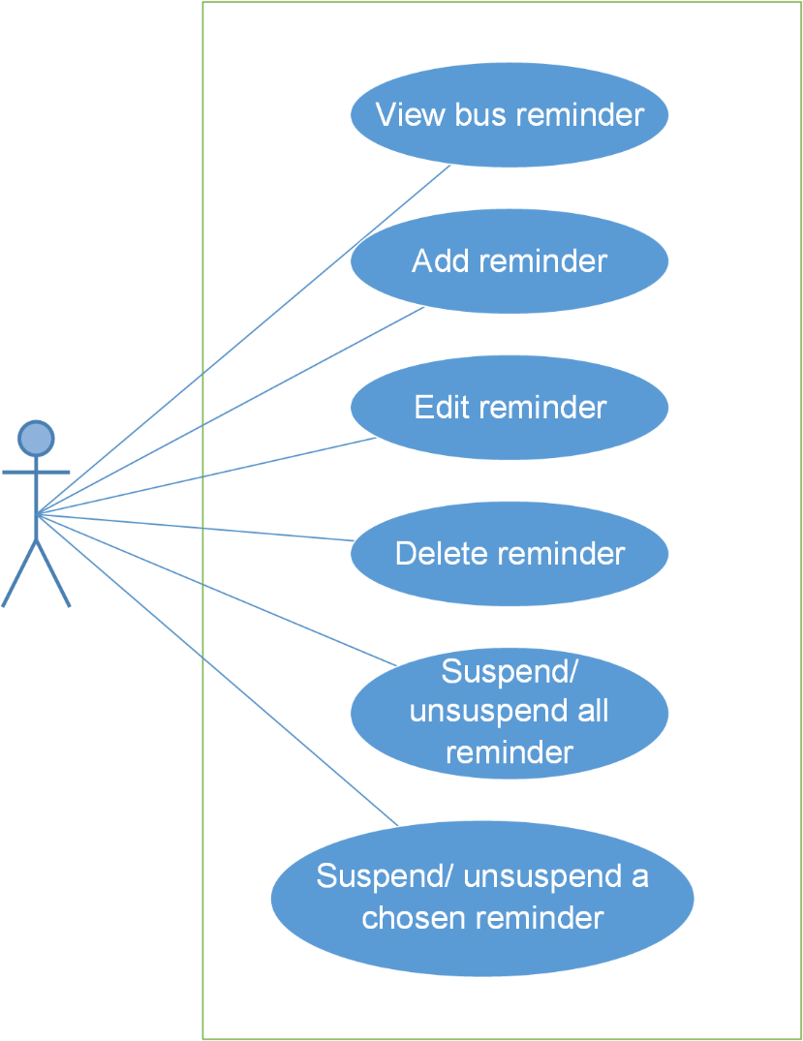

#### UC0020: View bus reminder

##### Screen definition

##### Use Case Specification

|  |  |  |  |  |
| --- | --- | --- | --- | --- |
| **Use Case ID** | | UC0020 | **Version** | 1.0 |
| **Use Name** | | View bus reminder | | |
| **Actor** | | BUIN User | | |
| **Description** | | The function allows an user to view bus reminders | | |
| **Precondition** | | “Dashboard” screen displayed | | |
| **Trigger** | | User taps “Nhắc nhở” button | | |
| **Post-Condition** | | “Xem nhắc nhở” screen is shown | | |
| **Main flows** | | | | |
| **Step** | **Actor** | **Action** | | |
| 1 | BUIN User | Taps “Nhắc nhở” button. | | |
| 2 | BUIN | Displays “Xem nhắc nhở” screen and shows list of reminder and the next reminder. If there isn’t any reminder, system will show message “Không có nhắc nhở nào” | | |
|  | | | | |

**Alternative scenario**

|  |  |  |
| --- | --- | --- |
| **AT1** | At step 1 in the main flows**,** if BUIN User taps Menu and chooses “Nhắc nhở” item | |
| **Step** | **Actor** | **Action** |
| 2.1 | BUIN | Displays “Xem nhắc nhở” screen and shows list of reminder and the next reminder. If there isn’t any reminder, system will show message “Không có nhắc nhở nào” |

#### UC0021: Add reminder

##### Screen definition

##### Use Case Specification

|  |  |  |  |  |
| --- | --- | --- | --- | --- |
| **Use Case ID** | | UC0021 | **Version** | 1.0 |
| **Use Name** | | Add reminder | | |
| **Actor** | | BUIN User | | |
| **Description** | | The function allows an user to add reminder | | |
| **Precondition** | | “Xem nhắc nhở” screen displayed | | |
| **Trigger** | | User taps “Thêm” button | | |
| **Post-Condition** | | “Thêm nhắc nhở” screen is shown | | |
| **Main flows** | | | | |
| **Step** | **Actor** | **Action** | | |
| 1 | BUIN User | Taps “Thêm” button. | | |
| 2 | BUIN | Displays “Thêm nhắc nhở” screen | | |
| 3 | BUIN User | Inputs “Thời gian”, “Điểm đi” và “Lặp lại” text field then taps “Thêm” button | | |
| 4 | BUIN | Displays “Hoàn thành thêm nhắc nhở” screen | | |
| 5 | BUIN User | Confirms reminder by tapping “Xong” button | | |
| 6 | BUIN | Saves reminder and returns “Xem nhắc nhở” screen. | | |
|  | | | | |

**Alternative scenario**

|  |  |  |
| --- | --- | --- |
| **AT1** | At step 1 in the main flows**,** if BUIN User taps Menu and chooses “Nhắc nhở” item | |
| **Step** | **Actor** | **Action** |
| 2.1 | BUIN | Displays “Xem nhắc nhở” screen and shows list of reminder and the next reminder. If there isn’t any reminder, system will show message “Không có nhắc nhở nào” |

|  |  |  |
| --- | --- | --- |
| **AT2** | At step 5 in the main flows**,** if BUIN User taps “Thêm” button | |
| **Step** | **Actor** | **Action** |
| 6.2 | BUIN | Displays “Thêm nhắc nhở” screen |
| 7.2 | BUIN User | Inputs “Thời gian”, “Điểm đi” và “Lặp lại” text field then taps “Thêm” button |
| 8.2 | BUIN | Displays “Hoàn thành thêm nhắc nhở” screen |
| 9.2 | BUIN User | Confirms reminder by tapping “Xong” button |
| 10.2 | BUIN | Saves reminder and returns “Xem nhắc nhở” screen. |

|  |  |  |
| --- | --- | --- |
| **AT3** | At step 1 in the main flows**,** if BUIN User enters “Danh sách buýt” screen and chooses a bus from list, then taps “Thêm nhắc nhở” button | |
| **Step** | **Actor** | **Action** |
| 2.3 | BUIN | Displays “Thêm nhắc nhở” screen |
| 3.3 | BUIN User | Inputs “Thời gian”, “Điểm đi” và “Lặp lại” text field then taps “Thêm” button |
| 4.3 | BUIN | Displays “Hoàn thành nhắc nhở” screen |
| 5.3 | BUIN User | Confirms reminder by tapping “Xong” button |
| 6.3 | BUIN | Saves reminder and returns “Xem nhắc nhở” screen. |

**Exception**

|  |  |  |
| --- | --- | --- |
| **E1** | At step 3 in the main flows**,** if BUIN User input a place which doesn’t exit into “Điểm đi” text field, then taps “Thêm” button. | |
| **Step** | **Actor** | **Action** |
| 4.1 | BUIN | Returns popup with Error message “Không tồn tại địa điểm này |

|  |  |  |
| --- | --- | --- |
| **E2** | At step 3 in the main flows**,** if BUIN User leaves “Điểm đi” text field blank, then taps Add Reminder button | |
| **Step** | **Actor** | **Action** |
| 4.2 | BUIN | Returns popup with Error message “Vui lòng nhập đầy đủ thông tin.” |
|  |  |  |

#### UC0022: Edit reminder

##### Screen definition

##### Use Case Specification

|  |  |  |  |  |
| --- | --- | --- | --- | --- |
| **Use Case ID** | | UC0022 | **Version** | 1.0 |
| **Use Name** | | Edit reminder | | |
| **Actor** | | BUIN User | | |
| **Description** | | The function allows an user to edit reminder | | |
| **Precondition** | | “Xem nhắc nhở” screen displayed | | |
| **Trigger** | | User taps on one Reminder | | |
| **Post-Condition** | | “Sửa nhắc nhở” screen is shown | | |
| **Main flows** | | | | |
| **Step** | **Actor** | **Action** | | |
| 1 | BUIN User | Taps on one Reminder | | |
| 2 | BUIN | Displays “Sửa nhắc nhở” screen | | |
| 3 | BUIN User | Edits “Thời gian”, “Điểm đi” và “Lặp lại” text field then taps “Sửa” button | | |
| 4 | BUIN | Displays “Hoàn thành nhắc nhở” screen | | |
| 5 | BUIN User | Confirms reminder by tapping “Xong” button | | |
| 6 | BUIN | Saves reminder and returns “Xem nhắc nhở” screen. | | |
|  | | | | |

**Exception**

|  |  |  |
| --- | --- | --- |
| **E1** | At step 3 in the main flows**,** if BUIN User input a place which doesn’t exit into “Điểm đi” text field, then taps “Thêm” button. | |
| **Step** | **Actor** | **Action** |
| 4.1 | BUIN | Returns popup with Error message “Không tồn tại địa điểm này |

|  |  |  |
| --- | --- | --- |
| **E2** | At step 3 in the main flows**,** if BUIN User leaves “Điểm đi” text field blank, then taps Add Reminder button | |
| **Step** | **Actor** | **Action** |
| 4.2 | BUIN | Returns popup with Error message “Vui lòng nhập đầy đủ thông tin.” |
|  |  |  |

#### UC0023: Delete reminder

##### Screen definition

##### Use Case Specification

|  |  |  |  |  |
| --- | --- | --- | --- | --- |
| **Use Case ID** | | UC0023 | **Version** | 1.0 |
| **Use Name** | | Delete reminder | | |
| **Actor** | | BUIN User | | |
| **Description** | | The function allows an user to delete reminder | | |
| **Precondition** | | “Xem nhắc nhở” screen displayed | | |
| **Trigger** | | User taps on one Reminder then taps “Xóa” button | | |
| **Post-Condition** | | “Xác nhận xóa” popup is shown | | |
| **Main flows** | | | | |
| **Step** | **Actor** | **Action** | | |
| 1 | BUIN User | Taps on one Reminder | | |
| 2 | BUIN | Displays “Sửa nhắc nhở” screen | | |
| 3 | BUIN User | Taps “Xóa” button | | |
| 4 | BUIN | Displays “Xác nhận xóa” dialog. | | |
| 5 | BUIN User | Taps “Đồng ý” button | | |
| 6 | BUIN | Deletes this reminder and comes back to Bus Reminder screen. | | |
|  | | | | |

**Exception**

|  |  |  |
| --- | --- | --- |
| **E1** | At step 5 in the main flows**,** if BUIN User taps “Hủy” button. | |
| **Step** | **Actor** | **Action** |
| 4.1 | BUIN | Do not delete anything and comes back to Reminder Detail screen |

#### UC0024: Suspend/Unsuspend all reminder

##### Screen definition

##### Use Case Specification

|  |  |  |  |  |
| --- | --- | --- | --- | --- |
| **Use Case ID** | | UC0024 | **Version** | 1.0 |
| **Use Name** | | Suspend/Unsuspend all reminder | | |
| **Actor** | | BUIN User | | |
| **Description** | | The function allows an user to suspend/unsuspend all reminder | | |
| **Precondition** | | “Xem nhắc nhở” screen displayed, “Gạt để hoãn tất cả nhắc nhở” switch button is OFF | | |
| **Trigger** | | User taps “Gạt để hoãn tất cả nhắc nhở” button | | |
| **Post-Condition** | | “Gạt để hoãn tất cả nhắc nhở” switch button turn from OFF to ON | | |
| **Main flows** | | | | |
| **Step** | **Actor** | **Action** | | |
| 1 | BUIN User | Taps “Gạt để hoãn tất cả nhắc nhở” switch button | | |
| 2 | BUIN | Suspends all reminders and hides them. | | |
| 3 | BUIN User | Taps “Gạt để hoãn tất cả nhắc nhở” switch button again | | |
| 4 | BUIN | Unsuspends all reminders and shows them. | | |
|  | | | | |

#### UC0025: Suspend/Unsuspend a chosen reminder

##### Screen definition

##### Use Case Specification

|  |  |  |  |  |
| --- | --- | --- | --- | --- |
| **Use Case ID** | | UC0025 | **Version** | 1.0 |
| **Use Name** | | Suspend/Unsuspend a chosen reminder | | |
| **Actor** | | BUIN User | | |
| **Description** | | The function allows an user to suspend/unsuspend a chosen reminder | | |
| **Precondition** | | “Xem nhắc nhở” screen displayed, “Gạt để hoãn tất cả nhắc nhở” switch button is OFF | | |
| **Trigger** | | User taps “Hoãn nhắc nhở” button | | |
| **Post-Condition** | | “Hoãn nhắc nhở” switch button turn from OFF to ON/ON to OFF | | |
| **Main flows** | | | | |
| **Step** | **Actor** | **Action** | | |
| 1 | BUIN User | Taps “Hoãn nhắc nhở” switch button | | |
| 2 | BUIN | Suspends that reminder | | |
| 3 | BUIN User | Taps “Hoãn nhắc nhở” switch button again | | |
| 4 | BUIN | Unsuspends that reminder | | |
|  | | | | |

### Track module

#### Use case diagram

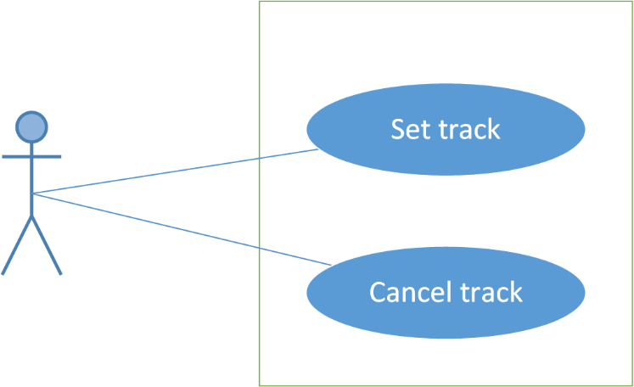

#### UC0026: Set track

##### Screen definition

##### Use Case Specification

|  |  |  |  |  |
| --- | --- | --- | --- | --- |
| **Use Case ID** | | UC0026 | **Version** | 1.0 |
| **Use Name** | | Set track | | |
| **Actor** | | BUIN User | | |
| **Description** | | The function allows an user to set track | | |
| **Precondition** | | “Thông tin buýt” screen displayed | | |
| **Trigger** | | User taps on “Đặt theo dõi” button then taps on one bus stop | | |
| **Post-Condition** | | “Theo dõi” screen is shown | | |
| **Main flows** | | | | |
| **Step** | **Actor** | **Action** | | |
| 1 | BUIN User | Taps “Đặt theo dõi” button | | |
| 2 | BUIN | Displays “Đặt theo dõi” screen | | |
| 3 | BUIN User | Taps on one bus stop | | |
| 4 | BUIN | Displays “Theo dõi” screen and shows where user is in the journey. When the bus comes near the predefined stop, system will notify the user to leave | | |
|  | | | | |

#### UC0027: Cancel track

##### Screen definition

##### Use Case Specification

|  |  |  |  |  |
| --- | --- | --- | --- | --- |
| **Use Case ID** | | UC0027 | **Version** | 1.0 |
| **Use Name** | | Set track | | |
| **Actor** | | BUIN User | | |
| **Description** | | The function allows an user to cancel track | | |
| **Precondition** | | “Theo dõi” screen displayed | | |
| **Trigger** | | User taps on “Hủy theo dõi” button | | |
| **Post-Condition** | | “Thông tin buýt” screen is shown | | |
| **Main flows** | | | | |
| **Step** | **Actor** | **Action** | | |
| 1 | BUIN User | Taps “Hủy theo dõi” button | | |
| 2 | BUIN | Cancels track and comes back to “Thông tin buýt” screen | | |
|  | | | | |

### Favorite module

#### Use case diagram

#### UC0028: View favorite places

##### Screen definition

##### Use Case Specification

|  |  |  |  |  |
| --- | --- | --- | --- | --- |
| **Use Case ID** | | UC0028 | **Version** | 1.0 |
| **Use Name** | | View favorite place | | |
| **Actor** | | BUIN User | | |
| **Description** | | The function allows a user to view the favorite place list he/she added before. | | |
| **Precondition** | | Dashboard screen displayed | | |
| **Trigger** | | User taps Menu then taps Favorite item | | |
| **Post-Condition** | | Favorite screen displayed | | |
| **Main flows** | | | | |
| **Step** | **Actor** | **Action** | | |
| 1 | BUIN User | Taps Menu then taps Favorite item | | |
| 2 | BUIN | Displays Favorite screen | | |
|  | | | | |

#### UC0029: Add favorite place

##### Screen definition

##### Use Case Specification

|  |  |  |  |  |
| --- | --- | --- | --- | --- |
| **Use Case ID** | | UC0029 | **Version** | 1.0 |
| **Use Name** | | Add favorite place | | |
| **Actor** | | BUIN User | | |
| **Description** | | The function allows a user to add the favorite place he/she cares. | | |
| **Precondition** | | Favorite Place screen displayed | | |
| **Trigger** | | User taps on Add button | | |
| **Post-Condition** | | Favorite Place screen displayed (new place added) | | |
| **Main flows** | | | | |
| **Step** | **Actor** | **Action** | | |
| 1 | BUIN User | Tap on Add button. | | |
| 2 | BUIN | Display Edit Favorite Place screen with blank info | | |
| 3 | BUIN User | Enter the place he/she want to search into the input form. | | |
| 4 | BUIN | Display a list of place which has name like the key word. | | |
| 5 | BUIN User | Tap on Heart item on this screen. | | |
| 6 | BUIN | The chosen place will be added in the favorite place list. | | |
|  | | | | |

#### UC0030: Edit favorite place

##### Screen definition

##### Use Case Specification

|  |  |  |  |  |
| --- | --- | --- | --- | --- |
| **Use Case ID** | | UC0030 | **Version** | 1.0 |
| **Use Name** | | Edit favorite place | | |
| **Actor** | | BUIN User | | |
| **Description** | | The function allows a user to edit the favorite place in the list. | | |
| **Precondition** | | Favorite Place screen displayed | | |
| **Trigger** | | User taps on one place then edit info and taps Done button | | |
| **Post-Condition** | | Favorite Place screen displayed (place edited) | | |
| **Main flows** | | | | |
| **Step** | **Actor** | **Action** | | |
| 1 | BUIN User | Taps on a favorite place. | | |
| 2 | BUIN | Displays Edit Favorite Place screen with information about it. | | |
| 3 | BUIN User | Edit favorite place’s name | | |
| 4 | BUIN | Displays edited name | | |
| 5 | BUIN User | Taps on favorite place’s location | | |
| 6 | BUIN | Displays map | | |
| 7 | BUIN User | Taps one location on map | | |
| 8 | BUIN | Gets that location and displays its coordinates | | |
| 9 | BUIN User | Taps Done button | | |
| 10 | BUIN | Displays Favorite Place screen with edited info | | |
|  | | | | |

**Alternative flows**

|  |  |  |
| --- | --- | --- |
| **AT1** | At step 7 on main scenario, if User taps Current location button | |
| **Step** | **Actor** | **Action** |
| 8.2 | BUIN | Gets current location and displays its coordinates |

#### UC0031: Delete favorite place

##### Screen definition

##### Use Case Specification

|  |  |  |  |  |
| --- | --- | --- | --- | --- |
| **Use Case ID** | | UC0031 | **Version** | 1.0 |
| **Use Name** | | Delete favorite place | | |
| **Actor** | | BUIN User | | |
| **Description** | | The function allows a user to delete the favorite place if he/she does not need anymore. | | |
| **Precondition** | | Favorite Place screen displayed | | |
| **Trigger** | | User taps on Delete button then taps Yes button | | |
| **Post-Condition** | | Displays Favorite Place screen (chosen place deleted) | | |
| **Main flows** | | | | |
| **Step** | **Actor** | **Action** | | |
| 1 | BUIN User | Taps on Delete button | | |
| 2 | BUIN | Displays Delete confirm notice | | |
| 3 | BUIN User | Taps on Yes button | | |
| 4 | BUIN | Deletes this place from database and displays Favorite Place screen | | |
|  | | | | |

#### UC0032: Search favorite place

##### Screen definition

##### Use Case Specification

|  |  |  |  |  |
| --- | --- | --- | --- | --- |
| **Use Case ID** | | UC0032 | **Version** | 1.0 |
| **Use Name** | | Search favorite place | | |
| **Actor** | | BUIN User | | |
| **Description** | | The function allows a user to search in the favorite place list. | | |
| **Precondition** | | Favorite Place displayed | | |
| **Trigger** | | User taps on Search item then input keyword | | |
| **Post-Condition** | | Favorite Place displayed (place searched) | | |
| **Main flows** | | | | |
| **Step** | **Actor** | **Action** | | |
| 1 | BUIN User | Taps on Search item. | | |
| 2 | BUIN | Displays Search form. | | |
| 3 | BUIN User | Inputs the place he/she want to search into the Search form. | | |
| 4 | BUIN | Displays a list of place which has name like the keyword. | | |
|  | | | | |

#### UC0033: View favorite buses

##### Screen definition

##### Use Case Specification

|  |  |  |  |  |
| --- | --- | --- | --- | --- |
| **Use Case ID** | | UC0033 | **Version** | 1.0 |
| **Use Name** | | View favorite bus | | |
| **Actor** | | BUIN User | | |
| **Description** | | The function allows a user to view the favorite bus list he/she added before. | | |
| **Precondition** | | Favorite Place screen displayed | | |
| **Trigger** | | User taps on Buses tab | | |
| **Post-Condition** | | Favorite Bus screen displayed | | |
| **Main flows** | | | | |
| **Step** | **Actor** | **Action** | | |
| 1 | BUIN User | Tap on Buses tab on the Favorite screen. | | |
| 2 | BUIN | Display Favorite screen with Buses tab. | | |
|  | | | | |

#### UC0034: Add favorite bus

##### Screen definition

##### Use Case Specification

|  |  |  |  |  |
| --- | --- | --- | --- | --- |
| **Use Case ID** | | UC0034 | **Version** | 1.0 |
| **Use Name** | | Add favorite bus | | |
| **Actor** | | BUIN User | | |
| **Description** | | The function allows a user to add the favorite bus he/she cares. | | |
| **Precondition** | | Favorite Bus screen displayed | | |
| **Trigger** | | User taps Add button then chooses a bus and taps Heart item | | |
| **Post-Condition** | | Favorite Bus screen displayed (new bus added) | | |
| **Main flows** | | | | |
| **Step** | **Actor** | **Action** | | |
| 1 | BUIN User | Taps on Add button | | |
| 2 | BUIN | Displays Bus List screen | | |
| 3 | BUIN User | Chooses a bus he/she want to add and taps on Heart item at the end of this line | | |
| 4 | BUIN | Displays Favorite Bus screen with new bus added | | |
|  | | | | |

#### UC0035: Delete favorite bus

##### Screen definition

##### Use Case Specification

|  |  |  |  |  |
| --- | --- | --- | --- | --- |
| **Use Case ID** | | UC0035 | **Version** | 1.0 |
| **Use Name** | | Delete favorite bus | | |
| **Actor** | | BUIN User | | |
| **Description** | | The function allows a user to delete the favorite place if he/she does not need anymore. | | |
| **Precondition** | | Favorite Bus screen displayed | | |
| **Trigger** | | User taps on Delete button and taps on Yes button | | |
| **Post-Condition** | | Favorite Bus screen displayed (chosen bus deleted) | | |
| **Main flows** | | | | |
| **Step** | **Actor** | **Action** | | |
| 1 | BUIN User | Taps on Delete button. | | |
| 2 | BUIN | Displays Delete confirm notice. | | |
| 3 | BUIN User | Taps on Yes button. | | |
| 4 | BUIN | Deletes this place from database and displays Favorite screen with Buses tab | | |
|  | | | | |

#### UC0036: Search favorite bus

##### Screen definition

##### Use Case Specification

|  |  |  |  |  |
| --- | --- | --- | --- | --- |
| **Use Case ID** | | UC0036 | **Version** | 1.0 |
| **Use Name** | | Search favorite bus | | |
| **Actor** | | BUIN User | | |
| **Description** | | The function allows a user to search in the favorite bus list. | | |
| **Precondition** | | Favorite Bus displayed | | |
| **Trigger** | | User taps on Search item then input keyword | | |
| **Post-Condition** | | Favorite Bus displayed (bus searched) | | |
| **Main flows** | | | | |
| **Step** | **Actor** | **Action** | | |
| 1 | BUIN User | Taps on Search item. | | |
| 2 | BUIN | Displays Search form. | | |
| 3 | BUIN User | Inputs the place he/she want to search into the Search form. | | |
| 4 | BUIN | Displays a list of bus which has name like the keyword. | | |
|  | | | | |

## Non-functional Specification

### Reliability

* Mean time between failures: The mean time between each failure is expected to be about 480 hours of using.
* Mean time to repair: Immediately when Administrator finds out problem or website is attacked/hacked by someone. Average 1 day.
* The maximum bugs per function are 2 bugs/a function when user uses software within 2 months. The average number of bugs in the software during system testing is about to be around 1 bugs/1000 LOC.
* The database must be backed up daily and can be recovered if necessary

### Performance Requirements

#### Availability

The application must be available 95% of time. Users can access to it everywhere from their

Android smartphones with an active internet connection and GPS enabled.

#### Response time

In term of response time, time for the app to fully load will not exceed 5 seconds. Accessing any function will not takes more than 1 second. Depending on the internet connections and GPS services, waiting time of requesting data will takes no more than 20 seconds in worst case.

### User Interface

* **Color:** The background color will mostly be dark grey by default. The color of text will be white by default. Accent colors is pink/green/yellow by default. These properties can be changed in the Settings menu.
* **Language:** Vietnamese by default. English option can be found in Settings menu.
* **Text:** All texts bases on the default Roboto font and title or label will use upper case in the first letter.
* **Graphics:** Big, bold, clear and colorful to attrack user’s attention.

### Maintainability

* **Coding standards and naming conventions**
  + Output of the project must include coding standards and naming conventions documentations. Implementation code must be easy to maintain.
  + All code must be clearly commented, including class, method documentations.
  + If some components are reused, the documentations of those components must also be included.
* **Design**
  + The design of the system must be loosely coupled that chances on some module will not affect others.
* **Logging**
  + All the errors should be logged, supporting for bug fixing and maintenance.
  + All strange or sensitive situations should also be logged.

### Usability

Usability Requirements support the following from the perspective of its primary users:

● **Efficiency of use:** user can complete each function in less than 8 actions

● **Intuitiveness:** all help/error messages are simple and easy to understand; user can figure out exactly how to use each feature after using it once.

### Security Requirements

In order to avoid unwanted access by strangers, the security implemented in various ways:

* **User layer**: User data will be stored at user’s devices and can be protected by basic security options provided by Android system itself. User data can be synchronized to server after user active this function with distinct username and password. There will also be a option to delete all user data on the current device – which will not affect synchronized data on server.
* **Manage Data Layer**: Only Administrator can modify database system. User data is encrypted by their password and is not accessible by any means.
* **Stored Data**: All synchronized user data will be saved in MSSQL Server and optimized for daily backup.

### Hardware/Software Requirements

● **Hardware requirement:** Android smartphones of all kinds (with active internet connection and GPS enabled)

● **Software requirements:** Android 4.4 or higher.